|  |  |  |  |
| --- | --- | --- | --- |
| Year 12 Worksheet 2 – Formative Assessment 2  **Motor Effect and induction** | | | |
|  | | | |
| **Name:** | **Teacher:** | **Score /15** | |
| **Comment:** | | | **Time allowed:**  **15 minutes** |

1. Draw a diagram of a single wire conductor going into the page, showing the direction of current going into the page and the magnetic field produced.

**(1 Mark)**

1. 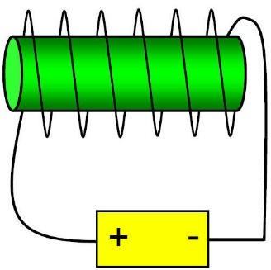Label the north and south ends of the two electromagnets shown:

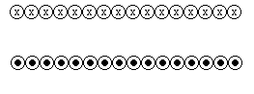

**(2 Marks)**

1. Two wires going with current travelling in the SAME direction, and placed near each other will:
   1. experience a force of attraction
   2. experience a force of repulsion
   3. not have any force between them. **(1 Mark)**
2. Examine the diagram to the right:

When the switch is turned the wire will experience a force in which direction?

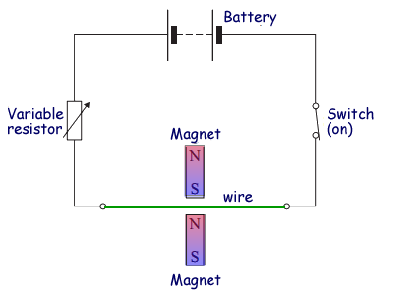

1. up
2. out of the page
3. down
4. into the page

**(1 Mark)**

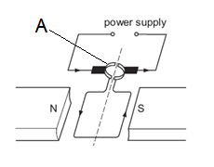

1. Examine the diagram left and:
2. Label the direction of rotation that you would expect.
3. Provide the full name of the part labelled A.

**(2 Marks)**

|  |  |
| --- | --- |
| 1. Diagram one of the below shows a wire being pushed into a magnetic field. The current that is produced is anticlockwise. Draw arrows to show the direction of the field between the magnets. | 1. On the wire, label the direction of the current that you would expect to be induced if the magnet is moved in the direction shown. |
|  | http://www.one-school.net/Malaysia/UniversityandCollege/SPM/Workbook/Physics/f5chp3/quizimage/induction_clip_image002_0003.jpg |
| **(1 Mark)** | **(1 Mark)** |
|  |  |

1. In the example of solenoids shown below, and given the changes stated, describe the current that will be induced in the secondary coil as either *“clockwise”, “anticlockwise”, or “none”.*
   1. 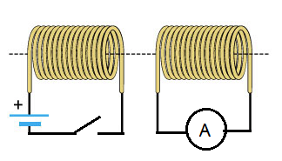The instant the Primary solenoid is turned on.
   2. Whilst the Primary solenoid is remains turned on.
   3. When the primary solenoid is turned off.

**(3 Marks)**

1. 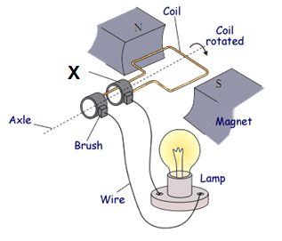The diagram to the right shows a simple generator
   1. What type of current will it produce?
   2. In the position that it is now in, **draw in** the direction of the induced current on the right side of the coil.
   3. What is the specific name for part X?

**(3 Marks)**